Who do I contact if I have any suggestions for improvement?
You may call the Probate Court ADA Coordinator, Vincent Russo, at 860-231-2442 or email your suggestions to vrusso@ctprobate.gov

Copyright © 2013, State of Connecticut Judicial Branch. Used with permission.

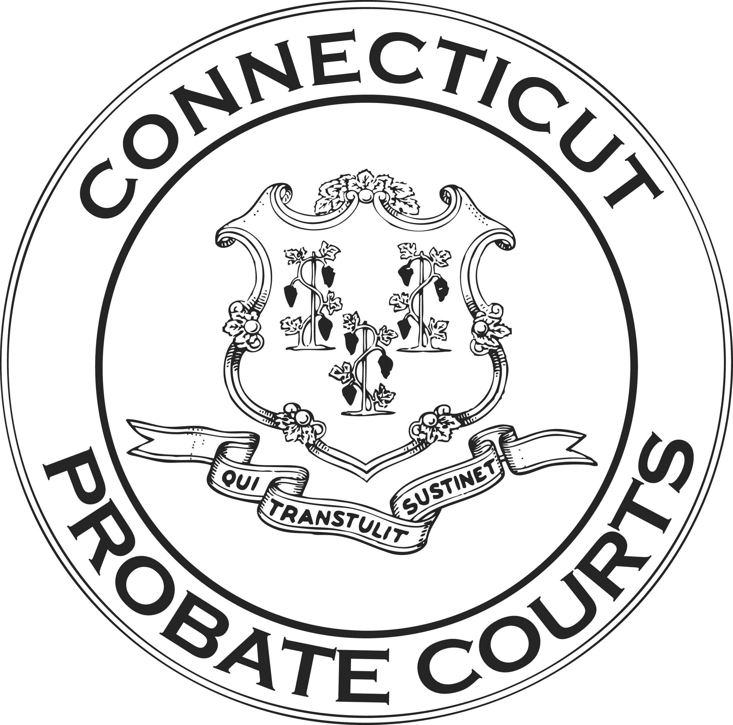

A Guide to
Understanding
The Americans With
Disabilities Act

Questions and Answers for
Members of the Public

www.ctprobate.gov
The Connecticut Probate Courts are committed to carrying out the objectives of the Americans with Disabilities Act (ADA). Title II of the ADA requires public entities, such as the Connecticut Probate Courts, to accommodate individuals with disabilities by providing equal access to their services, programs, and activities. This brochure was created to provide the public with reliable, easy to find ADA information. Please note that underlined words are “hyperlinks” to online versions of forms and other available information.

Under the ADA, one has a disability if one has a physical or mental impairment that substantially limits a major life activity, if one has a history of such an impairment, or is perceived to have an impairment. Major life activities include, but are not limited to, caring for oneself, performing manual tasks, seeing, hearing, eating, sleeping, walking, standing, lifting, bending, speaking, breathing, learning, reading, concentrating, thinking, communicating, and working.

In this brochure, you will find answers to common questions about the ADA and the courts. If you have other questions, you may speak to your local ADA contact person.

I will be visiting a Probate Court facility. Will there be an accessible entrance?
Yes. Every Probate Court facility has an accessible entrance. Please visit the court locations page on the Probate Court website, ctprobate.gov, to obtain the court’s address. If you do not have Internet access, please contact the court.

May I request an accommodation before I come to court?
Yes. It is best to make the request as far in advance as possible. You should give a minimum of 10 days’ notice.

I will be visiting a court, but I do not have a court case. Can I still make a request for an accommodation?
Yes. Anyone with a disability can make a request, whether that person is an attorney, a party to a case or a member of the public who simply wants to observe court proceedings.

How do I make a request for accommodation?
You can make a request in many different ways. You can fill out the Request for Accommodation By Persons With Disabilities, PC-2, which is available on the Probate Court website, or you can call the court or write to the ADA Contact at the court. The ADA Contact can answer specific questions about access to services and how to request accommodations. The list of ADA Contact people and their email addresses is on the Probate Court website.

Are ADA-related forms and information available in alternate formats?
Yes. The information can be available in other formats such as Braille, large print, and audio. However, you must request it and must provide us with enough notice to get it done. Ask your ADA Contact.

Can I get help filling out the form?

Yes. Feel free to ask the ADA Contact or any other court employee to help you fill out the form. However, they cannot give you legal advice.

What is the role of the ADA Contact?
An ADA Contact is available at each Probate Court facility to ensure there is someone at each location that can provide specific information about accommodations available at that location. The ADA Contact is not qualified, nor authorized, to act as an ADA attorney, expert, advocate or ADA compliance officer.

What information should I include on my Request for Accommodation form?
The accommodation request must include the full name, address and contact information of the person making the request. The request should also state, if you know it, the court date, the case number, and type of matter.

Do I have to tell you the nature of my disability?
Yes, the request should state the nature of the disability that makes an accommodation necessary and include a suggestion as to what would be a reasonable accommodation for the disability. Providing this information will allow the person reviewing your request to understand better the limitation or limitations you are facing, and provide you the most appropriate reasonable accommodation.

Do I need to prove that I have a disability?
Most requests for an accommodation do not require proof. In some cases, however, it may be necessary to provide additional information for the court to determine whether you are a “qualified” person with a disability under the law and/or to help identify the most appropriate reasonable accommodation.

Is the information I share with you confidential?

Yes. The Probate Courts are committed to maintaining confidentiality. The use of this information is solely to determine the need of an accommodation and to identify the most appropriate reasonable accommodation.

Can I request specific equipment or services to assist me?

Yes. The Probate Courts can make assistive listening devices, sign language interpreters, printed material in alternate formats, and real time transcription services available when appropriate. For a list of some available equipment and services, please visit the Probate Court website or call the ADA Contact at the facility that you will be visiting.

Can you provide an attorney to handle my court case?
No. The ADA does not require the Probate Court to provide a lawyer as an accommodation.

Can I request services of a personal nature?
No. The ADA does not require the Probate Court to provide services of a personal nature, such as legal representation, secretarial services, and transportation.

How much time do you need to review my request?
The review of each request begins immediately once received. However, in some instances, a request will require further consideration. You are notified of the decision as soon as possible.

Can my request be denied?

Yes. Although the Probate Courts are committed to ensuring that persons with disabilities have equal access to the courts, some requests may be denied.

Why would my request be denied?

An accommodation does not have to be approved if the person is not a “qualified” individual with a disability; if the accommodation causes a “fundamental alteration of a program or service”; or if it creates an “undue financial or administrative burden.” Additionally, the individual’s physical or mental impairment that substantially limits a major life activity must be directly related to the accommodation he/she is requesting.

What can I do if my request is denied?

If your request for an accommodation is denied, or if you do not agree with the accommodation offered, you can file a grievance/complaint. The grievance must be filed no later than 10 days after the denial has been made on your request. To find the grievance/ complaint form, or for additional information about the grievance process, please visit the Probate Court website or ask for assistance at the court.

I do not like the Judge’s decision in my case. Can I file an ADA complaint?
No. The ADA complaint process is used only when a request for accommodation has been denied. It is not the correct way to challenge a Judge’s decision.

Is there a cost for any of these services?
No. It is the Probate Court’s responsibility to provide a reasonable accommodation at no cost to all qualified individuals.

If I receive Supplemental Security Income (SSI), does that guarantee that my request for an accommodation will be approved?
No. The definition of disability under the Social Security Administration is not the same as the definition of disability under the ADA. The ADA defines it as having a physical or mental impairment that substantially limits a major life activity, having a record of, or being perceived as having such impairment.

